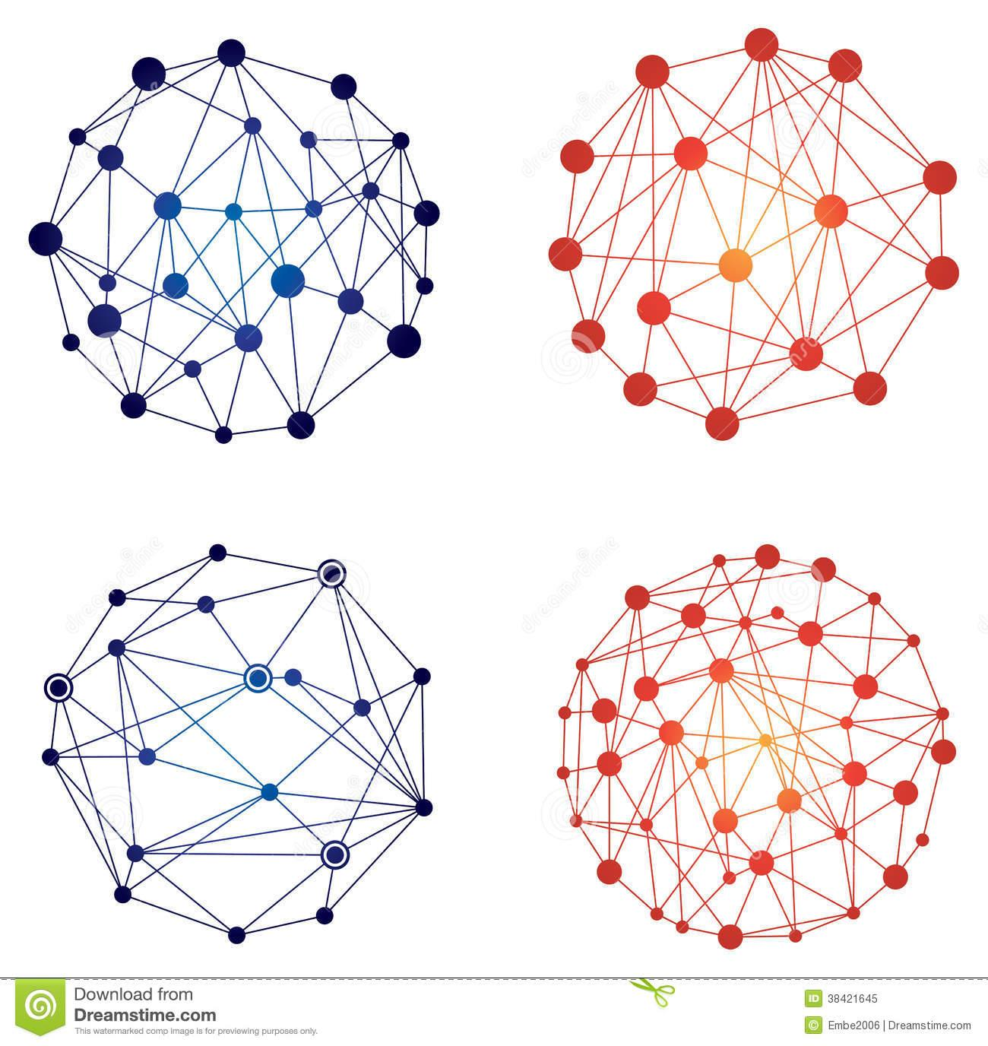

*MJCA, Inc.*

**Statement of Work**

**Presented by:**

CIS 4840-02

Group 2

Miguel Guzman Valle

Jesus Gonzalez

Celine Gee

Ana Duarte

Network Design Engineers

**Presented:**

15 May 2018

**Prepared for:**

**California State University, Los Angeles**

Table of Contents

***Executive Summary***……………………………………………………………………………...………2

***Project Schedule***………………………………………………………………………………………....2

***Introduction***………………………………………………………………………………………...……2

***Background***……………………………………………………………………………………………...2

***Scope of Work***………………………………………………………………………………………........3

***Feasibility Study***…………………………………………………………………………………………3

Project Situation………………………………………………………………………………………3

Network Scope………………………………………………………………………………………..3

Objectives……………………………………………………………………………………………..3

Design Features……………...………………………………………………………………………..4

Equipment Room……….………………………………………………………………..………....4

Computer Labs…………………..…………………………………………………………………4

Classrooms……………………....…………………………………………………………………4

Faculty Offices………………………………....…………………………………………………..4

Design Assumptions…….……………………………………………………………………………6

***Network Needs Analysis***…………………………………………………………………………………6

Data Types………………………………………………………………………………………...…6

Data Sources………………………………………………………………………………………....6

Numbers of Users and Priority Levels……………………………………………………………....6

Transmission Speed Requirements……………………………………………………....……….....7

Load Variation Estimates……………………………………………………………………………7

Reliability Requirements…………………………………………………………………………….7

Security Requirements……………………………………………………………………………....7

Existing Network………………………………………………………………………………….....7

Requirements………………………………………………………………………………………...8

***Network Logical Design***……………………………………………………………………..…………..9

***Network Diagrams and Topologies***………………………………………………………………...…..10

Exhibit A: California State University, Los Angeles Network Diagram..........................................10

Exhibit B: California State University, Los Angeles Network Diagram...........................................11

Exhibit C: Classroom........................................................................................................................12

Exhibit D: Computer Lab..................................................................................................................13

Exhibit E: Faculty Office Rooms:.....................................................................................................14

***System Components and Statement of Work***………………………………………….……………….15

***Disaster Recovery Plan***………………………………………………………………………..….........16

***Acceptance and Authorization***……………………………………………………………………........16

***Responsibilities***……………………………………………………………………................................17

***Product References***…..…………………………………………………………………........................19

***Executive Summary***

The proposal is to design a new network system for the 4th floor of the King Hall building located at California State University, Los Angeles (CSULA). Our plan for the network that we are designing considers the users of the network, capacity, and distance. Our goal is to design and implement a new local-area network (LAN) that will provide wireless and wired high speed internet access to the 4th floor of the King Hall building. Our implementation and design of the new local-area network (LAN) will incorporate physical and network software.

When gathering our information and throughout the extensive designing of the network, we kept in mind both the business and operational goals. Our intended users are mainly students, faculty, and staff; therefore, we took this information into account and created a logical design, as well as, a physical design to provide a better demonstration of how the network will operate. Our physical design shows greater details as to where the hardware will be placed and so forth.

***Project Schedule***

We have agreed to spend an ideal time of 3 weeks to complete the proposed project. It would be serviceable to go beyond that time frame and schedule the project for a month, or more than a month, but we have decided that it would not be as convenient as we should allocate that time to future potential projects that may cease to arise.

***Introduction***

MCJA, Inc. is a network design engineering company providing the design and implementation of local-area networks (LANs) to mid-to-large sized businesses with the mission of increasing student, faculty, and staff efficiency as well as enhance workflow at California State University, Los Angeles (CSULA).

Our names are Ana Duarte, Celine Gee, Miguel Guzman Valle, and Jesus Gonzalez and we are the Network Design Engineers assigned to this project by MJCA, Inc. We will be managing the design and implementation phase of the project. The budgeting of this project will be handled by the accounting department.

***Background***

The client, California State University, Los Angeles (CSULA) is located in Los Angeles, California. This is a public university that offers 129 bachelor's degrees, 112 master's degrees, and three doctoral degrees: a Ph.D. in special education, Doctor of Education, Doctor of Nursing Practices. We will be focusing on the King Hall building, which honors the late civil rights leader Martin Luther King, Jr., and is one of the busiest buildings on campus. It is home to a range of colleges and departments, including [Chicano/a studies](http://www.calstatela.edu/academic/chs/), [education](http://www.calstatela.edu/academic/ccoe/), [political science](http://www.calstatela.edu/dept/pol_sci/), [anthropology](http://www.calstatela.edu/academic/anthro/), [psychology](http://www.calstatela.edu/academic/psych/html/deptmenu.htm) and [history](http://www.calstatela.edu/academic/history/), among others. This building has 6 floors, but we will be working on the 4th floor, which is 49711.24 square feet, to develop and improve the needs of the building. This will allow for a broader range of wireless and wired high speed internet access for users.

***Scope of Work***

Work that will be performed includes the design and installation of a new fully switched hybrid topology with a tree network for the rooms. This will consist of the installation and setup of all the multi-functioning devices, cabling and interfaces; which may include, but is not limited to workstations, servers, switches, as well as, any further related software mentioned in the Security Requirements component.

***Feasibility Study:***

***Project Situation***

This proposal is for the design of a new local-area network system to service the 4th floor of the King Hall building located at California State University, Los Angeles (CSULA). Funding for this project is budgeted at $200,000 and is being financed by California State University, Los Angeles (CSULA) as a fragment of their construction costs.

***Network Scope***

The proposed network is designed to serve the 4th floor of the King Hall building located at California State University, Los Angeles (CSULA) which consists of approximately 105 rooms in a 49711.24 square foot floor. The King Hall building has been established since 1962, allowing us flexibility in the design of the installation of the network being proposed.

The rooms within the building will be an equipment room, computer lab, 56 classrooms, 44 faculty offices, 4 public restrooms, network components and connections.

***Objectives***

The network is designed to achieve several specific business and operational objectives:

1. *Network security*: The main goal is to maintain and provide stable network security to the King Hall building on the 4th floor of California State University, Los Angeles (CSULA). Reliable network security would allow to better protect internal systems from external users, requiring the user for authentication in order to access the network. Data and application access must be restricted and protected.
2. *High network performance*: Provide a high network performance through the implementation of a new network design. Increase performance at the access layer by implementing fast Ethernet and dedicated switch ports for all systems.
3. *Increase network availability*: Increasing network availability of any new network must implement redundant trunk links between switches, to avoid the failure of any link so that it will not impact the entire network. Enable local-area network (LAN) switches to be connected redundantly without creating broadcast storms that can slow response times.
4. *Increase network scalability*: The network design is scalable since the network requirements will change as funding from California State University, Los Angeles (CSULA) becomes obtainable. This is to ensure that the new network will be able to scale in a manner suitable to supporting new users, connections, and more.

***Intended Users*** The users of the network will consist of 32 part-time or full-time students in the computer lab, 1 administrator per workstation in classrooms, and 2 owners/administrators per workstation in faculty offices.

***Design Features:***

***Equipment Room***

This room will contain the necessary equipment that will be the base of the network on the 4th floor. As servers are located in another area in the building, routers will be connected to the internet offered by the internet service provider (ISP) and the servers through ethernet cable for a stable connection. The room will also have a uninterruptible power supply (UPS) to keep the electronics from failing in case of a blackout.

* Link to an internet connection
  + Router
  + Firewall
* 1 48-port Gigabit switch which will be the backbone of the data distribution through the 4th floor, as well as, it would allow to increase the network if required.

***Computer Labs***

The Computer Lab will possess 35 workstations, 32 for students use and 3 for faculty that will be in the room monitoring. Each workstation will consist of a computer, monitor with a built-in camera, keyboard, and mouse. A main switch will be used to connect to all of the devices. 4 workstations for students will be connected at a time to a switch, making it 2 switches for every column. Each switch will be connected individually to the wall plate, as well as, to each other. In case of failure, either by connection or dead switch, only 4 of the computers will not have a connection.

* 35 Workstations
* Cat 6 Cabling
* 24-port Switch
* 8 8-port Switch
* 3 Administrative Workstations
* 2 Network Printers
* 2 4-port Wall Plate
* 4 2-port Wall Plate

***Classrooms***

These rooms will only consist of the administrative workstation, but will have the necessary port if needed to increase the computers in the room.

* 1 workstation
* Cat 6 Cabling
* 8-port Switch
* 1 2-port Wall Plate
* 1 4-port Wall Plate

***Faculty Offices***

Faculty offices will consist of 2 administrative workstations and will have the necessary port provided in the case that the amount of computers in faculty offices is be to increased.

* 1 5-port switch
* 2 2-port Wall Plate
* Cat 6 Cabling
* 2 Workstations

***Design Assumptions***

This design presumes the following:

1. The network design and all of the equipment will be a new installation.
2. The King Hall building has no prior interior and is a new construction, allowing flexibility when designing the proposed network.
3. Internet service for wireless and wired high speed internet access is provided by an Internet Service Provider (ISP) such as Spectrum.
4. California State University, Los Angeles (CSULA) will provide specialized software to be installed on the networks.

***Network Needs Analysis:***

***Data Types***

Data types that will be served by the new network consists of personal information, financial information, and personal school accounts (CSULA school email, Canvas, Moodle, GET). They can be accessed in several ways through a wireless network. Students, faculty and staff can access the CSULA-SECURE wireless network using their MyCalStateLA ID username and password.

***Data Sources***

All sorts of data will be created and used across the network. There will be data produced by software applications in a Windows 10 environment, as well as, Apple’s MacOS Yosemite. Students will also have access to the latest software available on both their personal computer and California State University, Los Angeles (CSULA) hardware. The software available includes Adobe Creative Cloud, Autodesk, ChemDraw Prime, IBM SPSS Amos, IBM SPSS Statistics, Microsoft 2016/2019, Microsoft Office 365 ProPlus, Microsoft Security Essentials, Microsoft Windows 10, SAS, TechSmith Camtasia and Sangit, Wolfram Mathematica. The following vendors offer California State University, Los Angeles (CSULA) students, faculty, and staff discounts on the purchase of commonly used software for personal use.

* Kivuto Webstore
* ThinkEDU

***Numbers of Users and Priority Levels***

When dealing with the number of users that are going to be using the network at a given time that the maximum estimated number of users is roughly 1,800 or more. We know that the primary users will be faculty, students, and staff of the university. The maximum number of students in the largest room is about 30 students, with possible plans of expanding the network if needed. A small group of IT employees will be able to service and maintain the entire system for the 4th floor in the King Hall building.

***Transmission Speed Requirements***

Transmission speed requirements is the rate at which data is moved across a communication channel. Our local-area network (LAN) bandwidth speed will be up to par to keep up with California State University, Los Angeles (CSULA) needs: Ethernet Bandwidth 10/100 Mbps, Gigabit Ethernet 1,000 Mbps, 10 Gigabit Ethernet, 10,000 Mbps, Wi-Fi from 11 Mbps to 1,000+ Mbps.

***Load Variation Estimates***

According to the information California State University, Los Angeles (CSULA) has provided, the network’s busiest times will be from Monday-Friday between the times of 8am through 6pm, where as, Saturday through Sunday will be the least busiest days since there are less students on campus and there are no classes on Sunday.

***Reliability Requirements***

In order to keep up with faculty, staff, student user expectations, and, industry standards, the local-area network (LAN) will be expected to operate at 99.9% uptime and have an undiscovered error rate of .001%.

***Security Requirements***

Security is defined as the ability for a system to avoid being compromised by another entity. We will use a firewall designed to withstand both external and internal threats, it will be used so that unauthorized use is restricted. Users will be required to possess a login and password for a university account that will allow limited access to use the network. Access capabilities will differ depending on administrators and student users. Furthermore, we will incorporate routine data monitoring for internal tampering.

***Existing Networks***

No existing networks.

***Requirements***

* Software
  + Microsoft Windows 10 on all workstations (Wired or Wireless)
  + Microsoft Server 2018-2019 (Network Operating System)
  + Apple MacOS X Yosemite Server
  + Apple MacOS Mojave
  + Microsoft Office 2016/2019
  + Updates and service packs installed
  + CSU Software provided by the client
* Modem (provided by the ISP)
* Firewall
* Servers
* All connections needed
* Cabling and Connectors
* Wireless Access Points
* Switches
* Workstations
* Multifunction devices (print, copy, fax, scan)
* Monitors

***Network Logical Design***

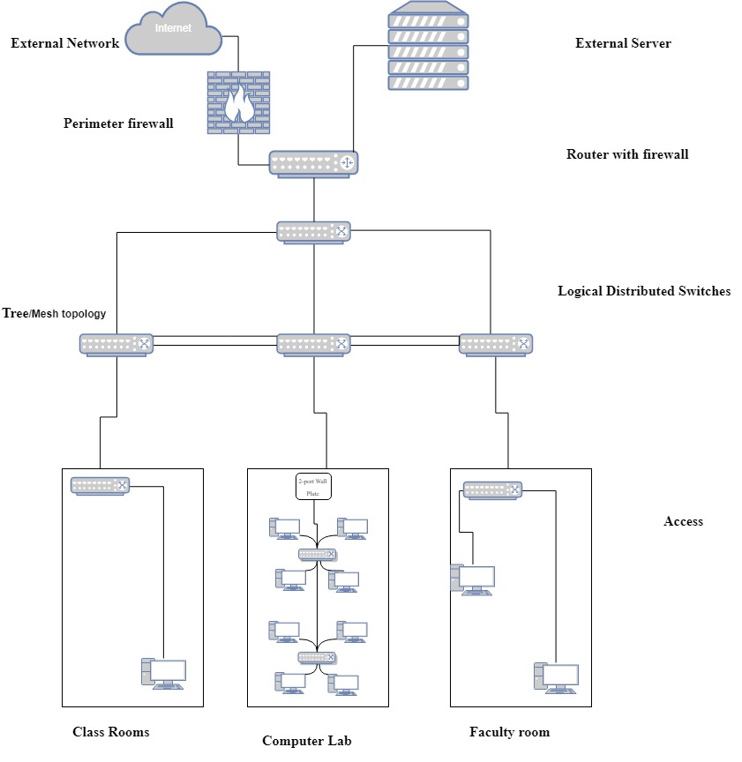

***Network Diagram and Topologies:***

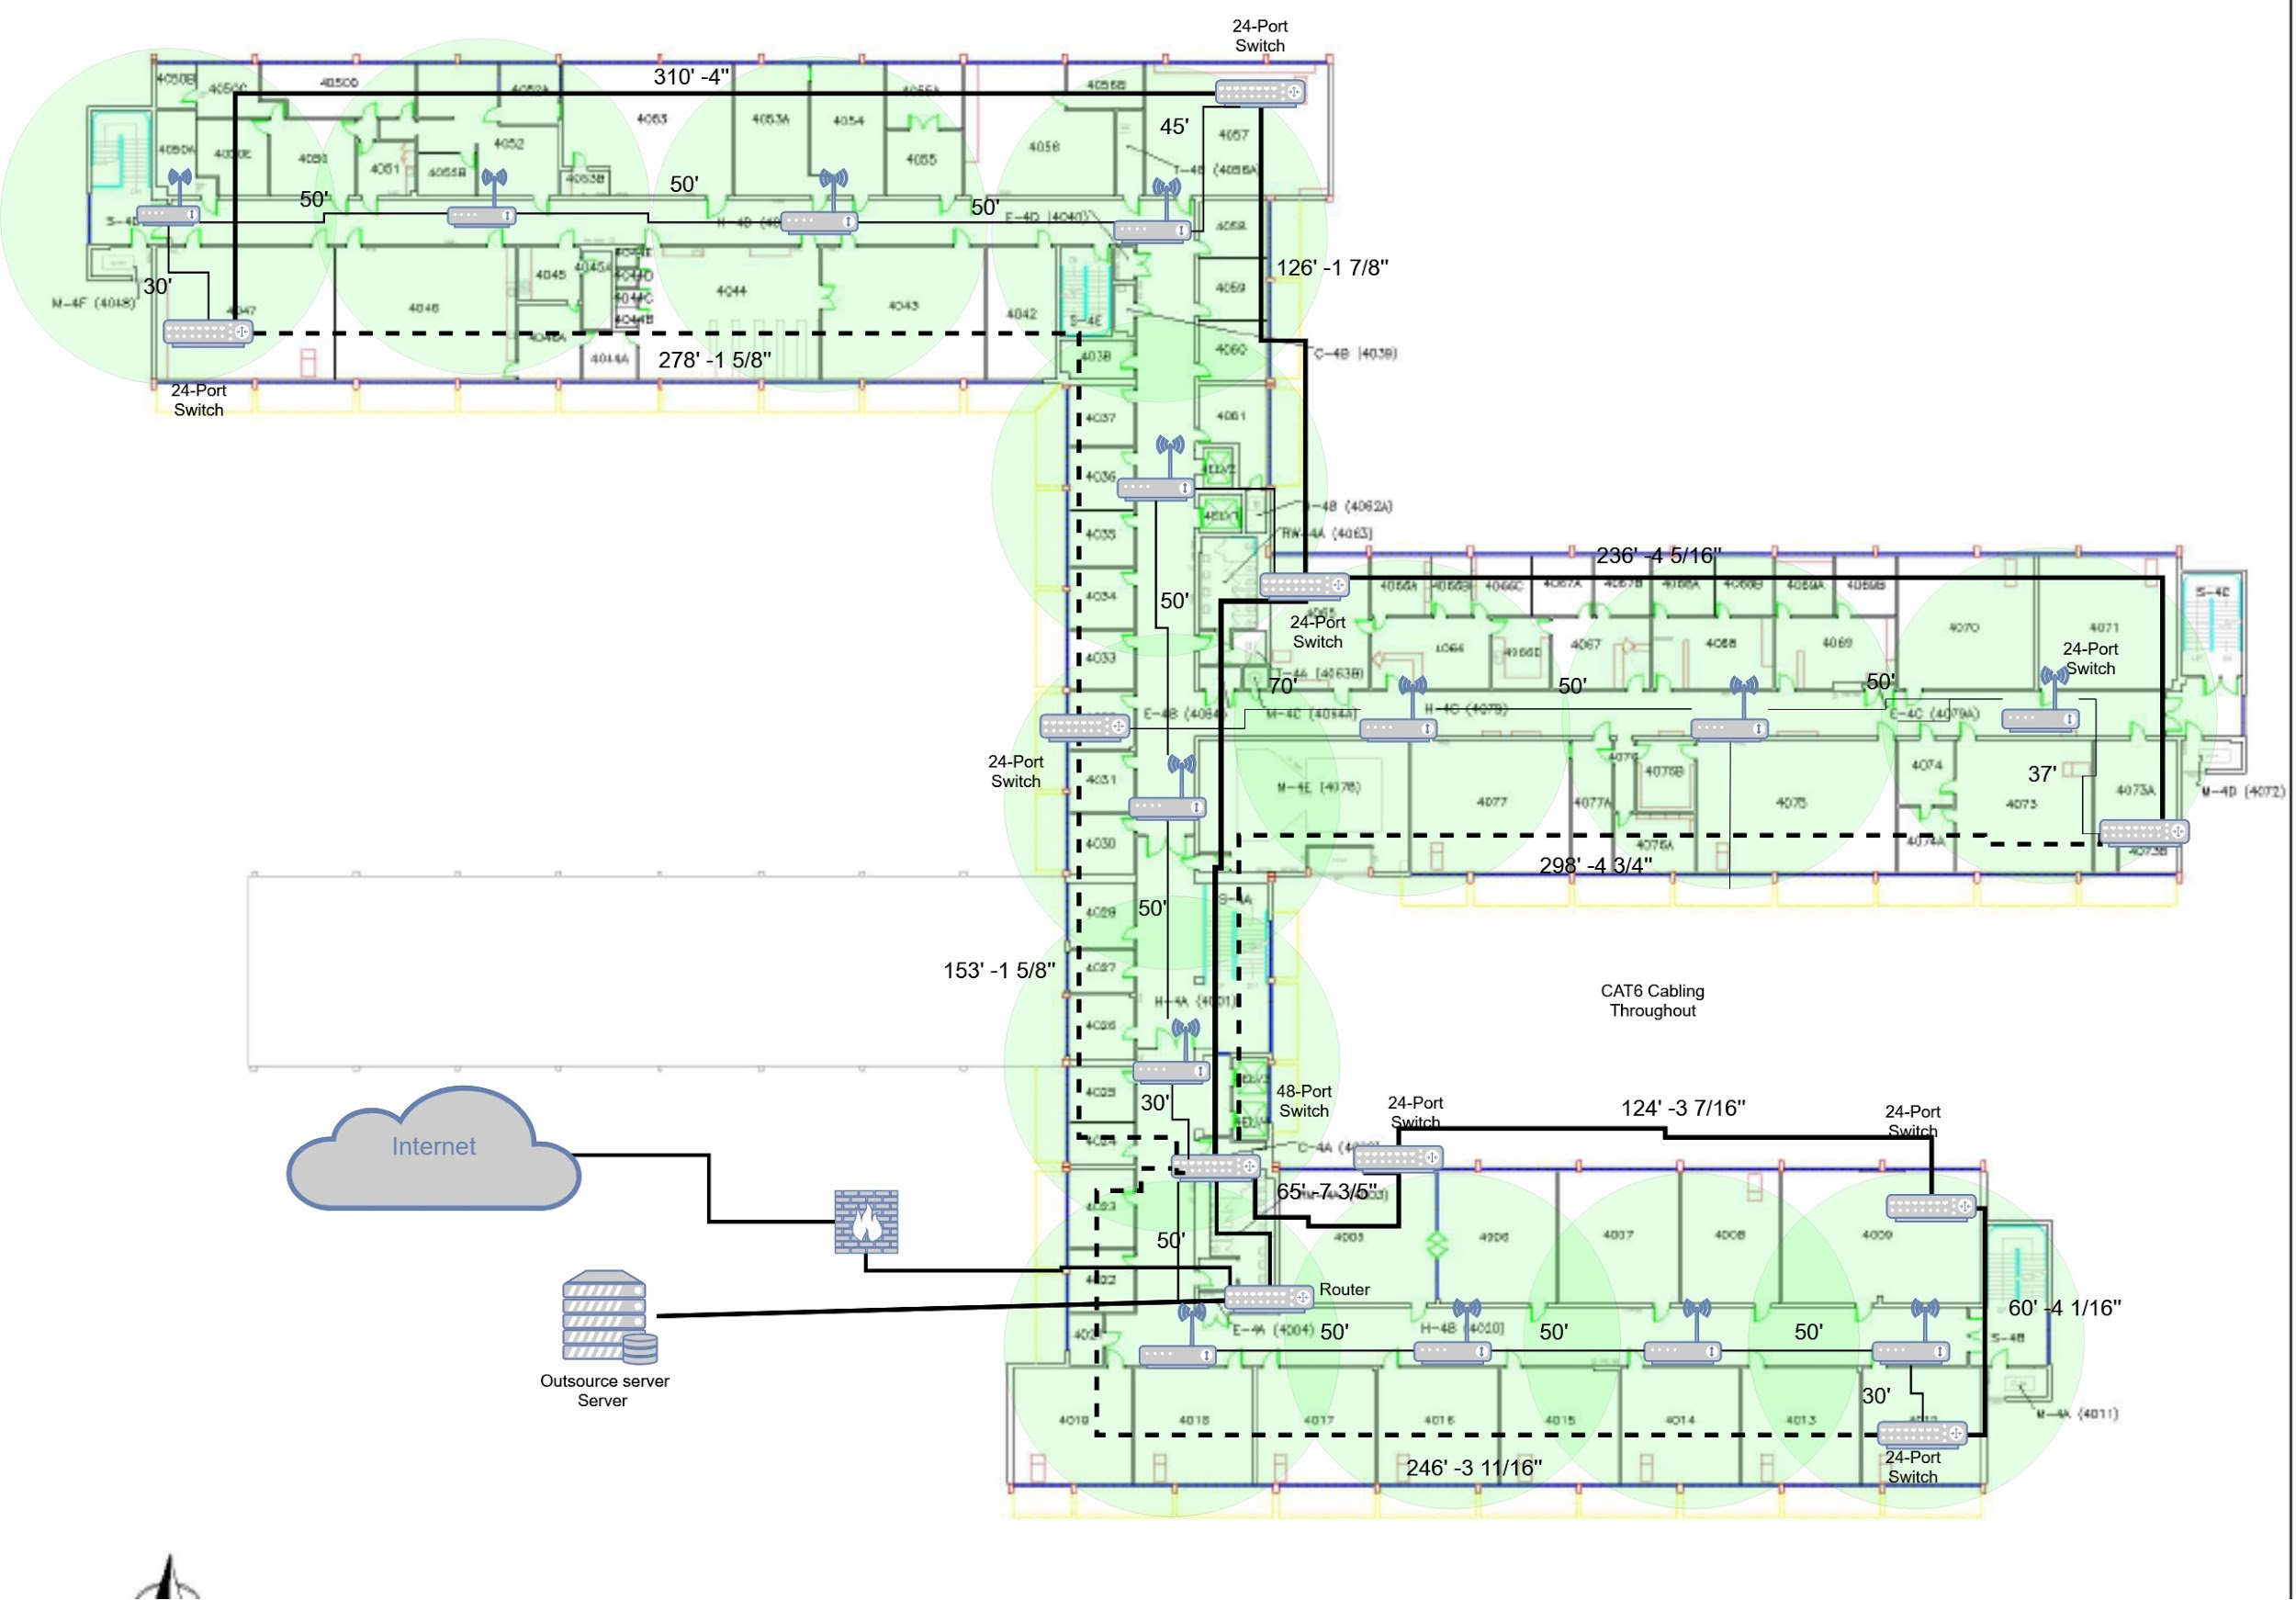

**Exhibit A: California State University, Los Angeles Network Diagram**

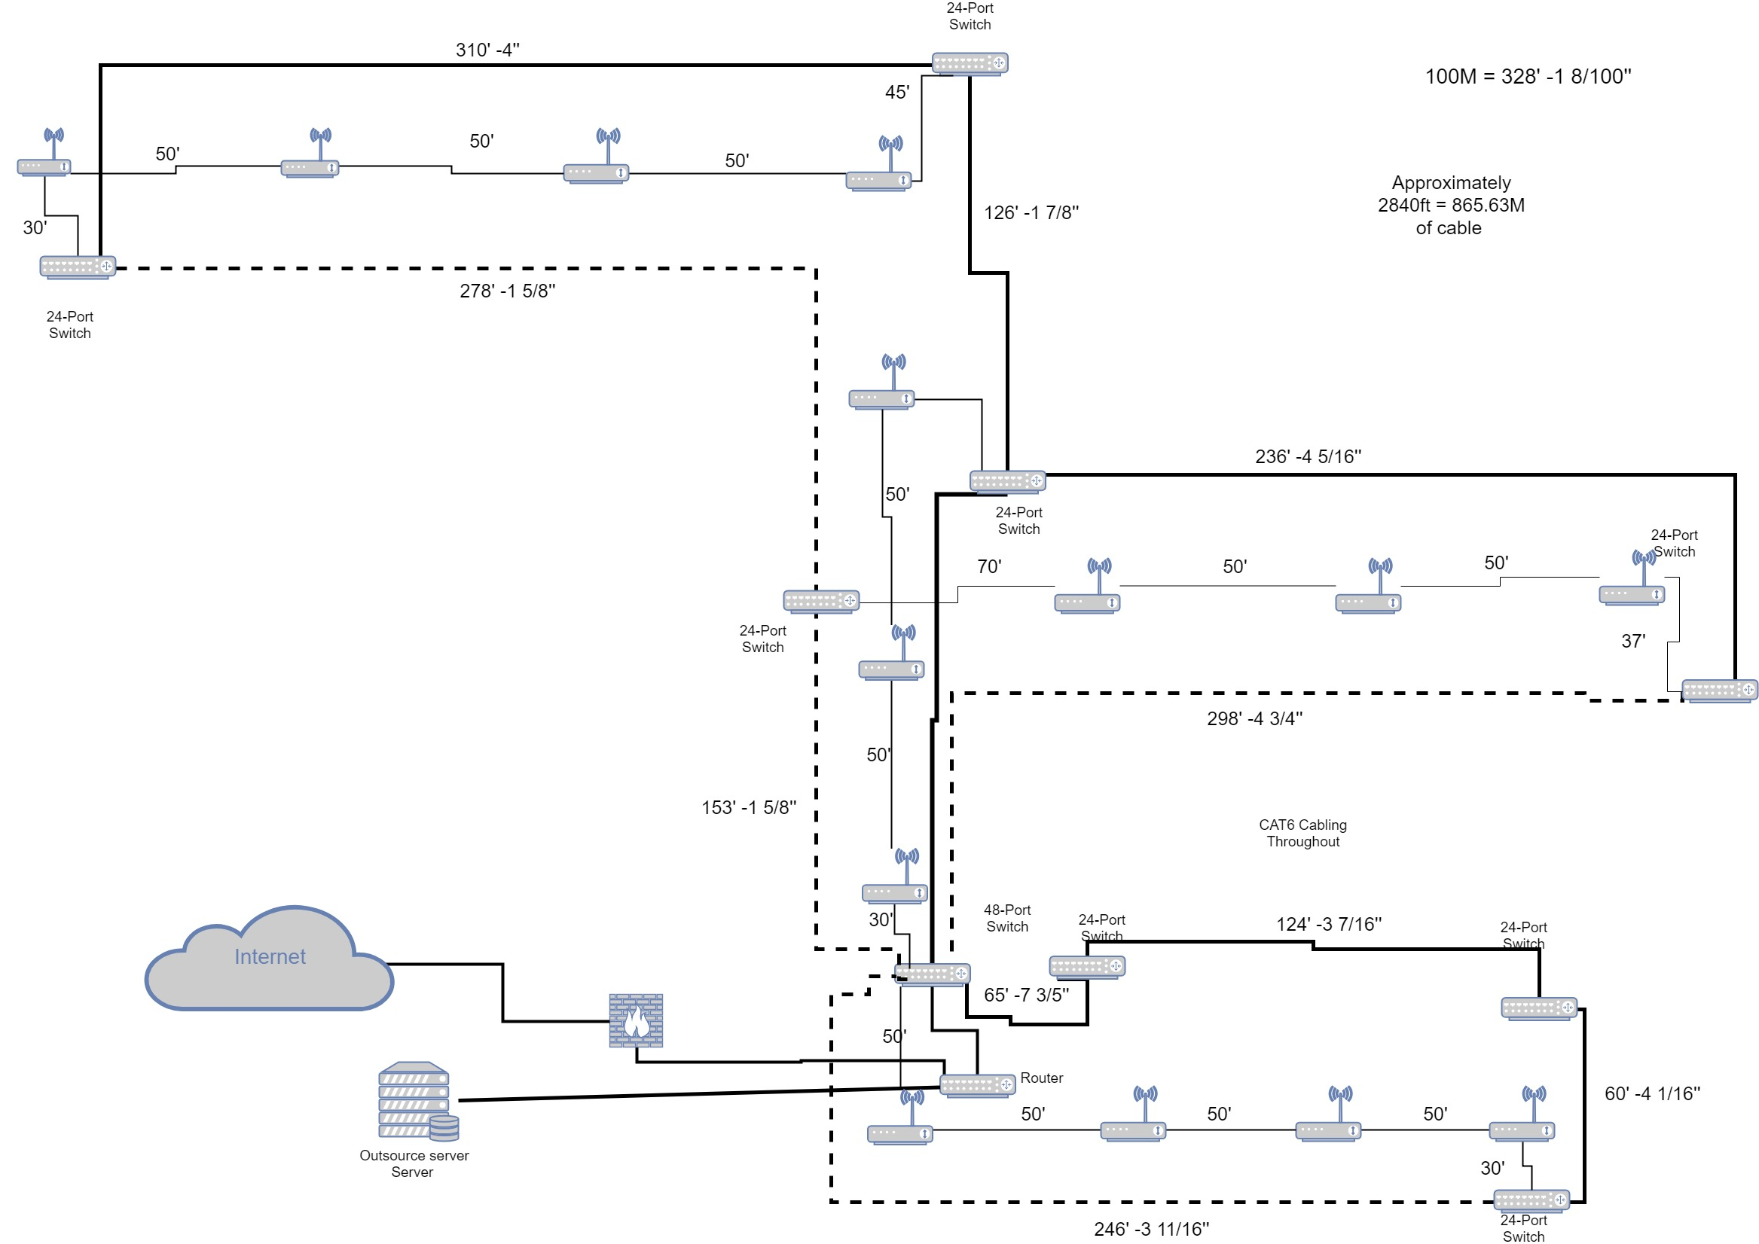

**Exhibit B: California State University, Los Angeles Network Diagram**

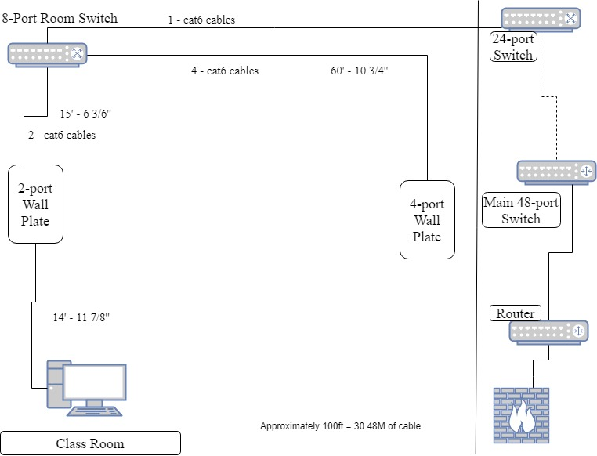

**Exhibit C: Classroom**

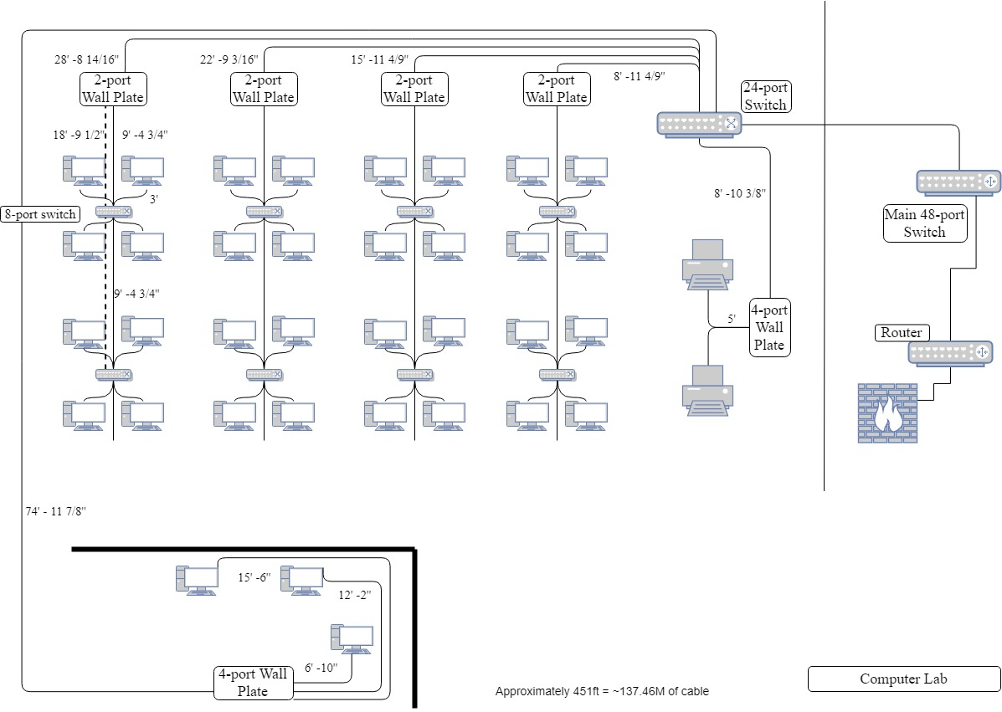

**Exhibit D: Computer Lab**

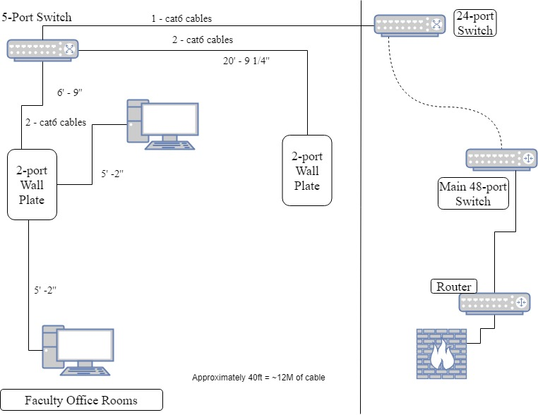

**Exhibit E: Faculty Office Rooms**

***System Components and Statement of Work***

|  |  |  |  |  |  |
| --- | --- | --- | --- | --- | --- |
| MJCA, Inc. | | | | | |
| System Components and Statement of Work | | | | | |
| Item | Units | Cost ea. | Total Cost | URL (click link to view) | Labor Est. |
| Work Stations | 102 | $934.00 | $95,268.00 | [Workstations](https://store.hp.com/us/en/mdp/desktops/elitedesk-800-mini-349547--1#!&tab=vao) | $1,000.00 |
| Monitors | 118 | $179.00 | $21,122.00 | [Monitor](https://store.hp.com/us/en/pdp/hp-elitedisplay-e243-238-inch-monitor) | $0.00 |
| Apple Machine | 8 | $1,099.00 | $8,792.00 | [Mac Mini 6-core](https://www.apple.com/shop/buy-mac/mac-mini) |  |
| Cable Management | 1 | $500.00 | $500.00 | [Cable management](https://www.newegg.com/Product/ProductList.aspx?Submit=ENE&DEPA=0&Order=BESTMATCH&Description=cable+management) | $0.00 |
| Cisco 1921 Router | 1 | $439.00 | $439.00 | [Cisco 1921 Router site](https://www.newegg.com/Product/Product.aspx?Item=N82E16833120491) | $300.00 |
| UPS | 1 | $609.00 | $609.00 | [APC Smart UPS SRT](https://www.apc.com/shop/us/en/products/APC-Smart-UPS-SRT-72V-2-2kVA-Battery-Pack/P-SRT72BP) | $50.00 |
| Licenses | 112 | $95.99 | $10,750.88 | [Microsoft Office 2019 Pro](https://softwareproworld.com/index.php/microsoft-office-2019.html) | $1,000.00 |
| Color Laser Printer/Scanner | 2 | $3,409.00 | $6,818.00 | [Canon Printer/Scanner](https://copyfaxes.com/product/7278/Canon-imageRUNNER-ADVANCE-C3525i-II-Color-Multifunction-Printer?utm_source=productlistingads&utm_medium=adwords&utm_campaign=adwords&gclid=CjwKCAjw8LTmBRBCEiwAbhh-6I0uOWx-e_yqipKAAYq8APNOPOGL9U_Qq3uHuJfWJEpG1caEFylX5RoCybYQAvD_BwE) | $120.00 |
| Cat 6 Cabling 1000 ft Rolls | 27 | $197.99 | $5,345.73 | [Cat6 Shielded Riser (CMR), 1000ft](https://www.amazon.com/Shielded-1000ft-Overall-Ethernet-trueCABLE/dp/B01JAVMD1I/ref=sr_1_1_sspa?keywords=Cat6+Riser+%28CMR%29%2C+1000ft&qid=1556658607&s=industrial&sr=1-1-spons&psc=1) | $3,486.24 |
| Cat6 RJ45 Ends 100 pack | 10 | $8.99 | $89.90 | [Cat6 RJ45 Ends](https://www.amazon.com/CableCreation-100-PACK-Connector-Connectors-Transparent/dp/B01K9Z4FT2/ref=pd_lpo_sbs_147_t_2?_encoding=UTF8&psc=1&refRID=Z4X9A0F63J9YKMDJ055V) | $0.00 |
| NETGEAR 48-Port Gigabit Ethernet Unmanaged Switch | 1 | $319.99 | $319.99 | [NETGEAR 48-Port Gigabit Ethernet Unmanaged Switch](https://www.amazon.com/NETGEAR-Ethernet-Unmanaged-Rackmount-GS324-100NAS/dp/B071KWTT8N/ref=sr_1_2_sspa?crid=IUR2KG8QCEDX&keywords=10%2Bport%2B1%2Bgig%2Bswitch&qid=1555876400&s=gateway&sprefix=1%2Bswitch%2B10%2Bport%2Caps%2C196&sr=8-2-spons&th=1) | $145.00 |
| NETGEAR 24-Port Gigabit Ethernet Unmanaged Switch | 10 | $109.99 | $1,099.90 | [NETGEAR 8-Port Gigabit Ethernet Unmanaged Switch](https://www.amazon.com/NETGEAR-Ethernet-Unmanaged-Rackmount-GS324-100NAS/dp/B01AX8XGQI/ref=sr_1_2_sspa?crid=IUR2KG8QCEDX&keywords=10%2Bport%2B1%2Bgig%2Bswitch&qid=1555876400&s=gateway&sprefix=1%2Bswitch%2B10%2Bport%2Caps%2C196&sr=8-2-spons&th=1) | $310.00 |
| NETGEAR 8-Port Gigabit Ethernet Unmanaged Switch | 58 | $27.99 | $1,623.42 | [NETGEAR 8-Port Gigabit Ethernet Unmanaged Switch](https://www.amazon.com/NETGEAR-Ethernet-Unmanaged-Rackmount-GS324-100NAS/dp/B00KFD0SEA/ref=sr_1_2_sspa?crid=IUR2KG8QCEDX&keywords=10%2Bport%2B1%2Bgig%2Bswitch&qid=1555876400&s=gateway&sprefix=1%2Bswitch%2B10%2Bport%2Caps%2C196&sr=8-2-spons&th=1) | $680.00 |
| NETGEAR 5-Port Gigabit Ethernet Unmanaged Switch | 44 | $22.99 | $1,011.56 | [NETGEAR 5-Port Gigabit Ethernet Unmanaged Switch](https://www.amazon.com/NETGEAR-Ethernet-Unmanaged-Rackmount-GS324-100NAS/dp/B00QR6XFHQ/ref=sr_1_2_sspa?crid=IUR2KG8QCEDX&keywords=10%2Bport%2B1%2Bgig%2Bswitch&qid=1555876400&s=gateway&sprefix=1%2Bswitch%2B10%2Bport%2Caps%2C196&sr=8-2-spons&th=1) | $560.00 |
| 4 Port Cat 6 Wall Plate 100 pack | 1 | $1,179.97 | $1,179.97 | [Point 4 Port Cat6 Wall Plate](https://www.amazon.com/Buyers-Point-Female-Female-Voltage-Mounting/dp/B07JRC3HX9/ref=sr_1_3?crid=2WRH7PSE0B3VE&keywords=cat5e%2Bwall%2Bplate%2B4%2Bport&qid=1555908652&s=gateway&sprefix=cat5e%2Bwall%2B%2Caps%2C432&sr=8-3&th=1) | $350.00 |
| 2 Port Cat 6 Wall Plate 100 pack | 2 | $765.97 | $1,531.94 | [2 Port Cat6 Wall Plate](https://www.amazon.com/Buyers-Point-Female-Female-Voltage-Mounting/dp/B07JQSCQKM/ref=sr_1_3?crid=2WRH7PSE0B3VE&keywords=cat5e%2Bwall%2Bplate%2B4%2Bport&qid=1555908652&s=gateway&sprefix=cat5e%2Bwall%2B%2Caps%2C432&sr=8-3&th=1) | $380.00 |
| Ubiquiti Networks PRO Access Point 6 pack | 2 | $801.00 | $1,602.00 | [Ubiquiti Networks Access Point](https://www.amazon.com/gp/product/B07JY6131X/ref=as_li_tl?ie=UTF8&camp=1789&creative=9325&creativeASIN=B015PRO512&linkCode=as2&tag=mbr08-20&linkId=045ae5507d667ba5d75ee8ce9bb2f42b&th=1) | $540.00 |
| Firewall | 1 | $1,645.00 | $1,645.00 | [SonicWall TZ600](https://www.firewalls.com/products/firewalls/sonicwall/sonicwall-tz/tz-600/dell-sonicwall-tz-600-hardware-only.html) | $450.00 |
|  |  |  |  |  |  |
| **Total** |  |  | $159,748.29 |  | $9,371.24 |
|  |  |  |  | **Grand Total** | **$169,119.53** |

***Disaster Recovery Plan***

* Disaster Recovery Plan: Involves a thorough analysis of the network structure, application, equipment, and related details.
* Disaster Recovery Team: California State University, Los Angeles (CSULA) should be able to provide IT employees capable of overseeing the network in the 4th floor of the King Hall building. The team should be composed of members of each department with representatives from top management.
* Checklist and Flow of Diagrams: In case of network disruption, having an idea of both the location and organization of all network cabling and network equipment can help to provide a high-level view of response and recovery.
* Equipment Failure: In case of equipment failure, depending on the equipment, a downtime of network activity will be bound to happen in an area of the 4th floor. In that case identifying the affected area through network failover detection as soon as possible and replace the damaged equipment will be the first priority. Having the extra equipment in case of an emergency can also help bring the system back up and running faster.

***Acceptance and Authorization***

This authorizes and allows MJCA, Inc. in conjunction with California State University Los Angeles (CSULA) to apply full service and the products listed on the documents as part of their service and work.

California State University, Los Angeles MJCA, Inc.

_______________________________ ______________________________

Full Name Full name

_______________________________ ______________________________

Title Title

_______________________________ ______________________________

Signature Signature

_______________________________ ______________________________

Date Date

***Responsibilities***

***Ana Duarte & Celine Gee***

* Introduction
* Background
* Scope of Work
* Feasibility Study:
  + Project Situation
  + Network Scope
  + Objectives
  + Design Features:
    - Classrooms
    - Faculty Offices
  + Design Assumptions
* System Components and Statement of Work
* Review and Editing

***Jesus Gonzalez***

* Executive Summary
* Project Schedule
* Network Need Analysis:
  + Data Types
  + Data Sources
  + Number of Users and Priority Levels
  + Transmission Speed Requirements
  + Load Variation Estimates
  + Reliability Requirements
  + Security Requirements
  + Existing Networks
  + Requirements

***Miguel Guzman Valle***

* Feasibility Study
  + Design Features:
    - Equipment Room
    - Computer Labs
* Network Logical Design
* Network Diagram and Topologies:
  + Exhibit A: California State University, Los Angeles Network Diagram
  + Exhibit B: California State University, Los Angeles Network Diagram
  + Exhibit C: Classrooms
  + Exhibit D: Computer Lab
  + Exhibit E: Faculty Office Rooms
* System Components and Statement of Work
* Disaster Recovery Plan
* Acceptance and Authorization

***Product References***

Work Stations

<https://store.hp.com/us/en/mdp/desktops/elitedesk-800-mini-349547--1#!&tab=vao>

Monitors

<https://store.hp.com/us/en/pdp/hp-elitedisplay-e243-238-inch-monitor>

Apple Machine

<https://www.apple.com/shop/buy-mac/mac-mini>

Cable Management

<https://www.newegg.com/Product/ProductList.aspx?Submit=ENE&DEPA=0&Order=BESTMATCH&Description=cable+management>

Cisco 1921 Router

<https://www.newegg.com/Product/Product.aspx?Item=N82E16833120491>

UPS

<https://www.apc.com/shop/us/en/products/APC-Smart-UPS-SRT-72V-2-2kVA-Battery-Pack/P-SRT72BP>

Licenses - Microsoft Office 2019 Pro

<https://softwareproworld.com/index.php/microsoft-office-2019.html>

Color Laser Printer/Scanner

<https://copyfaxes.com/product/7278/Canon-imageRUNNER-ADVANCE-C3525i-II-Color-Multifunction-Printer?utm_source=productlistingads&utm_medium=adwords&utm_campaign=adwords&gclid=CjwKCAjw8LTmBRBCEiwAbhh-6I0uOWx-e_yqipKAAYq8APNOPOGL9U_Qq3uHuJfWJEpG1caEFylX5RoCybYQAvD_BwE>

Cat 6 Cabling 1000 ft rolls

<https://www.amazon.com/Shielded-1000ft-Overall-Ethernet-trueCABLE/dp/B01JAVMD1I/ref=sr_1_1_sspa?keywords=Cat6+Riser+%28CMR%29%2C+1000ft&qid=1556658607&s=industrial&sr=1-1-spons&psc=1>

Cat 6 RJ45 Ends 100 pack

<https://www.amazon.com/CableCreation-100-PACK-Connector-Connectors-Transparent/dp/B01K9Z4FT2/ref=pd_lpo_sbs_147_t_2?_encoding=UTF8&psc=1&refRID=Z4X9A0F63J9YKMDJ055V>

NETGEAR 48-Port Gigabit Ethernet Unmanaged Switch

<https://www.amazon.com/NETGEAR-Ethernet-Unmanaged-Rackmount-GS324-100NAS/dp/B071KWTT8N/ref=sr_1_2_sspa?crid=IUR2KG8QCEDX&keywords=10%2Bport%2B1%2Bgig%2Bswitch&qid=1555876400&s=gateway&sprefix=1%2Bswitch%2B10%2Bport%2Caps%2C196&sr=8-2-spons&th=1>

NETGEAR 24-Port Gigabit Ethernet Unmanaged Switch

<https://www.amazon.com/NETGEAR-Ethernet-Unmanaged-Rackmount-GS324-100NAS/dp/B01AX8XGQI/ref=sr_1_2_sspa?crid=IUR2KG8QCEDX&keywords=10%2Bport%2B1%2Bgig%2Bswitch&qid=1555876400&s=gateway&sprefix=1%2Bswitch%2B10%2Bport%2Caps%2C196&sr=8-2-spons&th=1>

NETGEAR 8-Port Gigabit Ethernet Unmanaged Switch

<https://www.amazon.com/NETGEAR-Ethernet-Unmanaged-Rackmount-GS324-100NAS/dp/B00KFD0SEA/ref=sr_1_2_sspa?crid=IUR2KG8QCEDX&keywords=10%2Bport%2B1%2Bgig%2Bswitch&qid=1555876400&s=gateway&sprefix=1%2Bswitch%2B10%2Bport%2Caps%2C196&sr=8-2-spons&th=1>

NETGEAR 5-Port Gigabit Ethernet Unmanaged Switch

<https://www.amazon.com/NETGEAR-Ethernet-Unmanaged-Rackmount-GS324-100NAS/dp/B00QR6XFHQ/ref=sr_1_2_sspa?crid=IUR2KG8QCEDX&keywords=10%2Bport%2B1%2Bgig%2Bswitch&qid=1555876400&s=gateway&sprefix=1%2Bswitch%2B10%2Bport%2Caps%2C196&sr=8-2-spons&th=1>

4-Port Cat 6 Wall Plate 100 pack

<https://www.amazon.com/Buyers-Point-Female-Female-Voltage-Mounting/dp/B07JRC3HX9/ref=sr_1_3?crid=2WRH7PSE0B3VE&keywords=cat5e%2Bwall%2Bplate%2B4%2Bport&qid=1555908652&s=gateway&sprefix=cat5e%2Bwall%2B%2Caps%2C432&sr=8-3&th=1>

2-Port Cat 6 Wall Plate 100 pack

<https://www.amazon.com/Buyers-Point-Female-Female-Voltage-Mounting/dp/B07JQSCQKM/ref=sr_1_3?crid=2WRH7PSE0B3VE&keywords=cat5e%2Bwall%2Bplate%2B4%2Bport&qid=1555908652&s=gateway&sprefix=cat5e%2Bwall%2B%2Caps%2C432&sr=8-3&th=1>

Ubiquiti Networks PRO Access Point 6 pack

<https://www.amazon.com/gp/product/B07JY6131X/ref=as_li_tl?ie=UTF8&camp=1789&creative=9325&creativeASIN=B015PRO512&linkCode=as2&tag=mbr08-20&linkId=045ae5507d667ba5d75ee8ce9bb2f42b&th=1>

Firewall

<https://www.firewalls.com/products/firewalls/sonicwall/sonicwall-tz/tz-600/dell-sonicwall-tz-600-hardware-only.html>